**LAB NO: 01**

|  |
| --- |
| Lab Tasks |
| Submission Date: 12-04-18 |

1. Draw ERDs for the following case studies:
   1. The study team identified a preliminary set of 11 entity types that describe the data required by the hospital in support of the various business functions: FACILITY, PHYSICIAN, PATIENT, DIAGNOSTIC UNIT, WARD, STAFF, ORDER, SERVICE/ DRUG, MEDICAL/SURGICAL ITEM, SUPPLY ITEM, and VENDOR. From discussions with hospital staff, reviewing hospital documents, and studying existing information systems, the study team developed a list of business rules describing the policies of the hospital and nature of the hospital’s operation that govern the relationships among these entities. Some of these rules follow:

* A FACILITY maintains one or more DIAGNOSTIC UNITs (radiology, clinical laboratory, cardiac diagnostic unit, etc.).
* A FACILITY contains a number of WARDs (obstetrics, oncology, geriatrics, etc.).
* Each WARD is assigned a certain number of STAFF members (nurses, secretaries, etc.); a STAFF member may be assigned to multiple WARDs.
* A FACILITY staffs its medical team with a number of PHYSICIANs. A PHYSICIAN may be on the staff of more than one FACILITY.
* A PHYSICIAN treats PATIENTs, and a PATIENT is treated by any number of PHYSICIANs.
* A PHYSICIAN diagnoses PATIENTs, and a PATIENT is diagnosed by any number of PHYSICIANs.
* A PATIENT may be assigned to a WARD (outpatients are not assigned to a WARD). The hospital cares only about the current WARD a patient is assigned to (if assigned at all).
* A PATIENT uses MEDICAL/SURGICAL ITEMs, which are supplied by VENDORs. A VENDOR also provides SUPPLY ITEMs that are used for housekeeping and maintenance purposes.
* A PHYSICIAN writes one or more ORDERs for a PATIENT. Each ORDER is for a given PATIENT, and a PATIENT may have many ORDERs.
* An ORDER can be for a diagnostic test (lab tests such as lipid profile, CBC, liver function tests; diagnostic imaging such as MRIs and X-rays) or a drug.

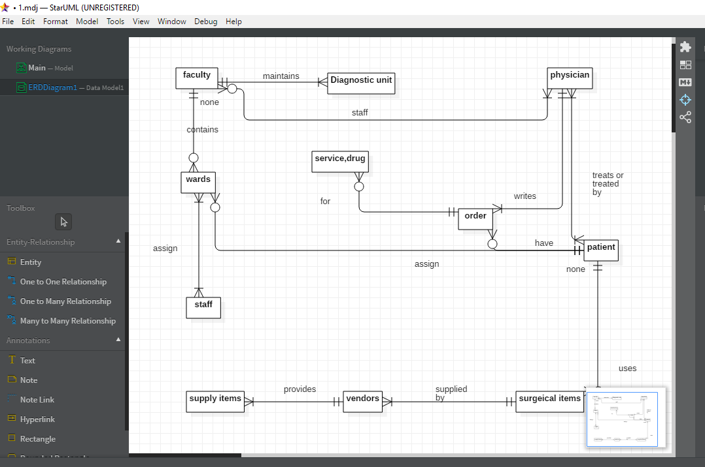

1. For each of the descriptions below, perform the following tasks:

i. Identify the degree and cardinalities of the relationship.

ii. Express the relationships in each description graphically ewith a logical design ER diagram.

1. A book is identified by its ISBN number, and it has atitle, a price, and a date of publication. It is publishedby a publisher, which has its own ID number and aname. Each book has exactly one publisher, but onepublisher typically publishes multiple books overtime
2. A piano manufacturer wants to keep track of all thepianos it makes individually. Each piano has an identifyingserial number and a manufacturing completiondate. Each instrument represents exactly one pianomodel, all of which have an identification number anda name. In addition, the company wants to maintain informationabout the designer of the model. Over time,the company often manufactures thousands of pianosof a certain model, and the model design is specifiedbefore any single piano exists.
3. A piano manufacturer (see above) employs piano technicianswho are responsible for inspecting the instrumentsbefore they are shipped to the customers. Each piano isinspected by at least two technicians (identified by theiremployee number). For each separate inspection, thecompany needs to record its date and a quality evaluationgrade.
4. The piano technicians (see above) have a hierarchy ofreporting relationships: Some of them have supervisoryresponsibilities in addition to their inspection roleand have multiple other technicians report to them. Thesupervisors themselves report to the chief technician ofthe company.
5. The entity type STUDENT has the following attributes:Student Name, Address, Phone, Age, Activity, and No ofYears. Activity represents some campus-based student activity,and No of Years represents the number of years thestudent has engaged in this activity. A given student mayengage in more than one activity. Draw a logical ERD for this situation.What attribute or attributes did you designate as theidentifier for the STUDENT entity? Why?
6. A college course may have one or more scheduled sectionsor may not have a scheduled section. Attributes ofCOURSE include Course ID, Course Name, and Units.Attributes of SECTION include Section Number andSemester ID. Semester ID is composed of two parts:Semester and Year. Section Number is an integer (such as 1 or 2) that distinguishes one section from another forthe same course but does not uniquely identify a section.How did you model SECTION? Why did you choosethis way versus alternative ways to model SECTION?

TASKS:

